Lets Upgrade

ASSINGMENT

BY:SARANG.P.P

1Q:Find out the mail servers of the following domain :

1\* Ibm.com

2\* Wipro.com

1 Answer : 1\* :

$open command prompt

$ type nslook up

$type set type=mx

$ Type ibm.com

$ results

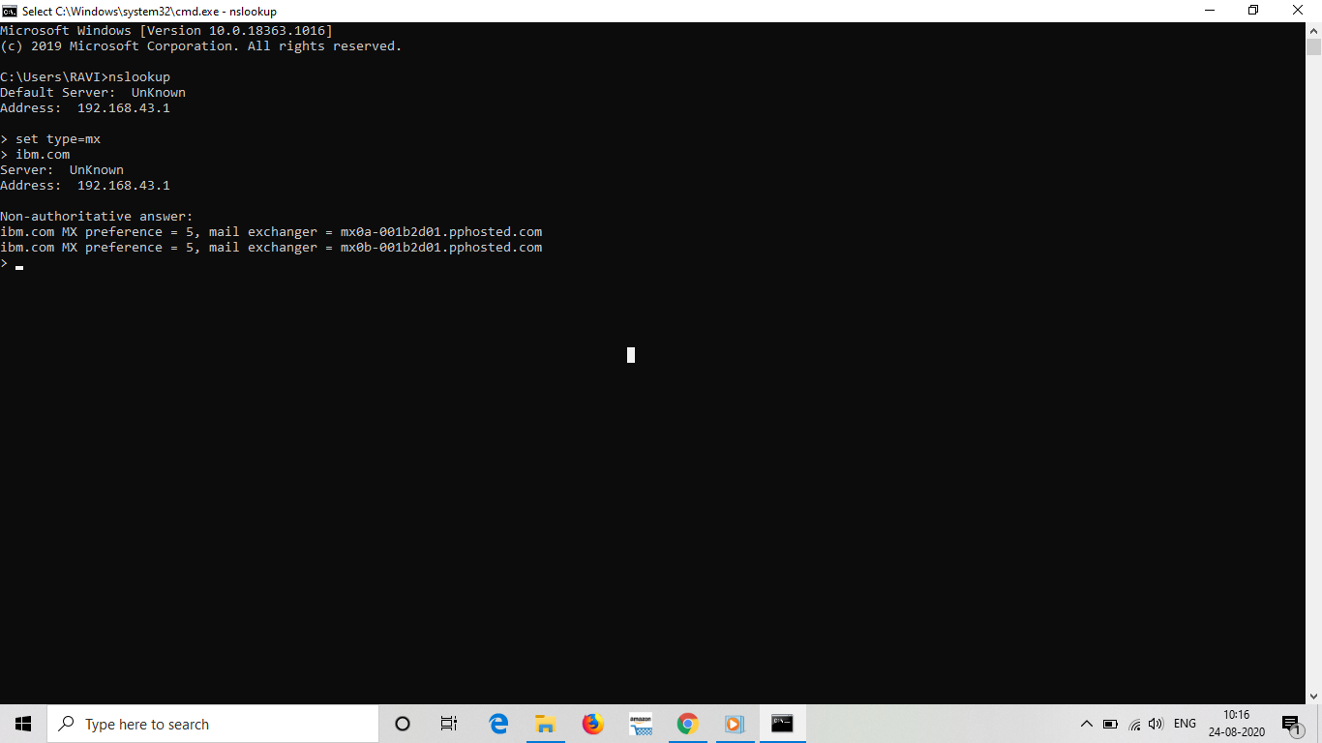

Conclusion :ibm.com has 2 mail servers which are = mx0a-001b2d01.pphosted.com

= mx0b-001b2d01.pphosted.com

1 Answer :2\* :

$open command prompt

$ type nslook up

$type set type=mx

$ Type wipro.com

$ results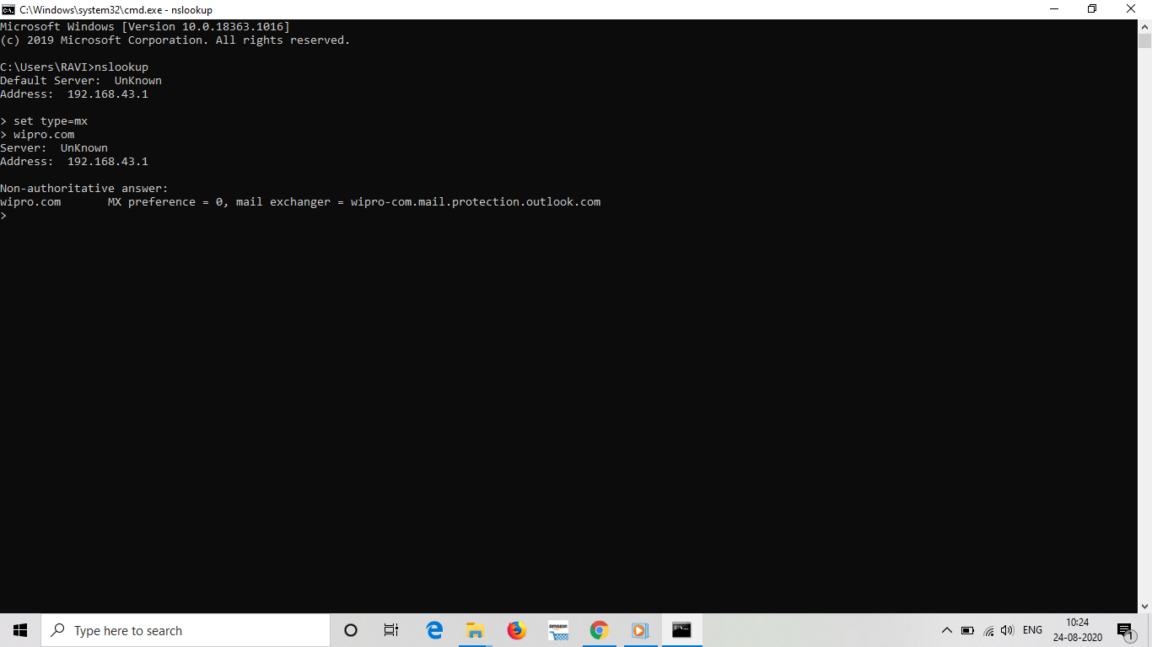

Conclusion:wipro.com has 1 mail server which iswipro-com.mail.protection.outlook.com

2 Q: Find the locations, where these email servers are hosted.

2 Answer : mx0b-001b2d01.pphosted.com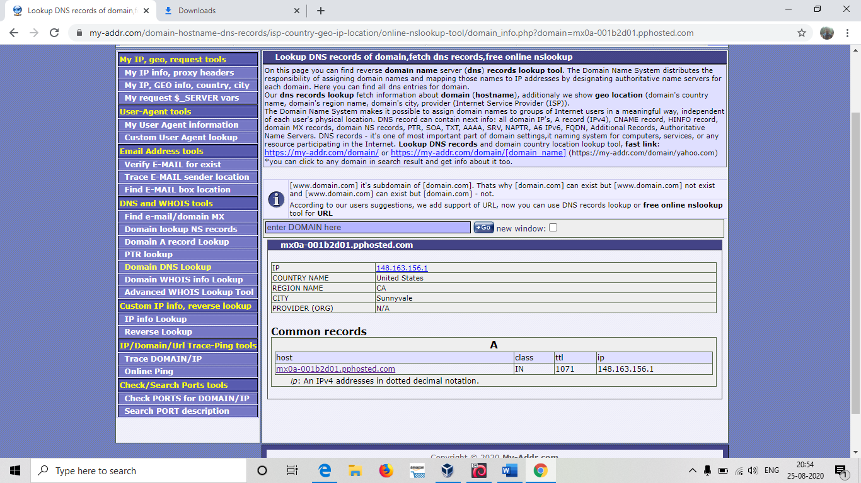

Location =

Country--------------United state

City--------------------Sunnyvale

mx0a-001b2d01.pphosted.com

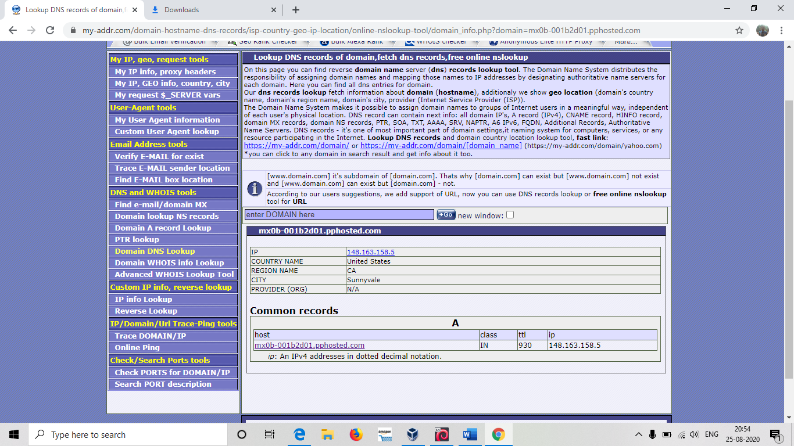

Location =

Country-------------- United states

City-------------------Sunnyvale

wipro-com.mail.protection.outlook.com

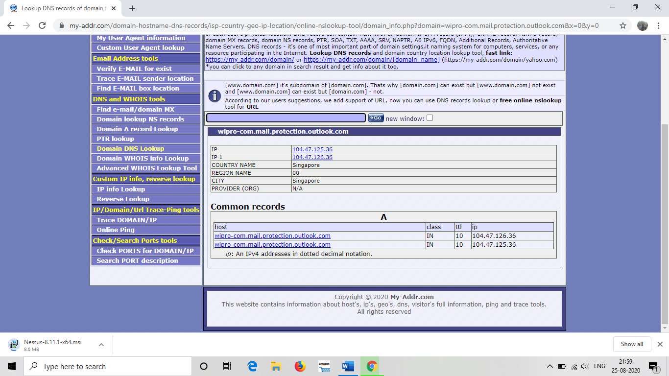

Location=

Country-----------------Singapore

City----------------------Singapore

3 Q:Scan and find out port numbers open 203.163.246.23

3 Answer:$ open terminal in kali linux

$ type sudonmap 203.163.246.23

$ type your password

$ result

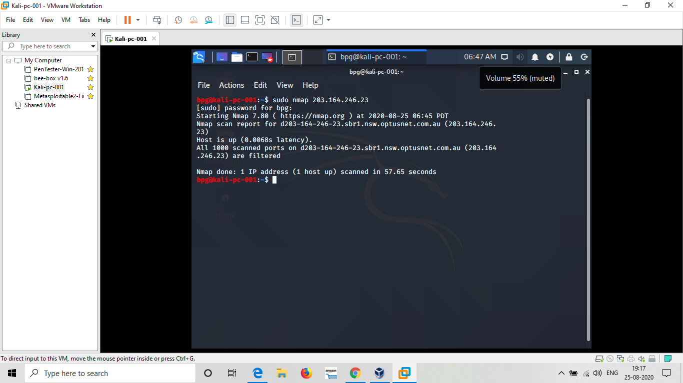

Conclusion: there is no open port all 100 where scanned but all are filtered (has firewall)

Sir I cannot install nessus,

In VM ware , when pentester is opened my laptop gets a hang and some times it will not open pentester,Just shows VMware…